

DEPARTMENT OF INFORMATION TECHNOLOGY
SCHOOL OF COMPUTING AND INFORMATICS

LOGBOOK: MOBILE APPLICATION DEVELOPMENT
UNIT CODE: BIT4107
NAME: YUSUF ANEMBA
REGNO: BIT/2020/90745
PROJECT NAME: SCHOOL MANAGEMENT APPLICATION

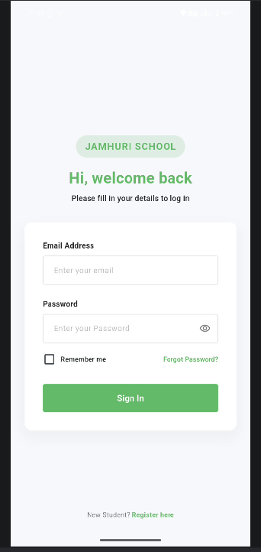
Figure 1.1 login page.
Students already enrolled will log in as their details have already been created and stored, while for new students, they will register and have their accounts created and their information stored.
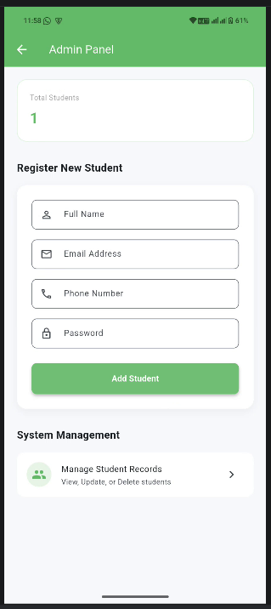
Figure 1.2 registration of new students
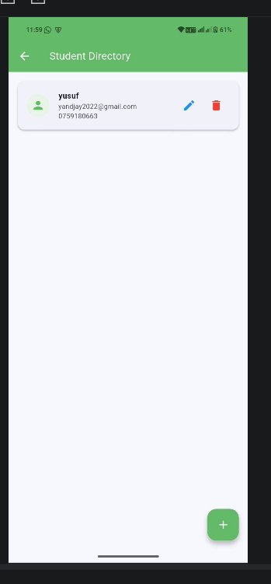
Figure 1.3 management of existing students records

TOOLS AND TECHNOLOGIES USED
For the development of the JAMHURI STUDENT MANAGENT APP, I used the following tools,
- Flutter SDK
- Dart
- SQFlite. Local database to store students’ records.
- Android studio
- Android emulator/ my android phone

